|  |  |
| --- | --- |
| Date | 19 September 2022 |
| Team ID | PNT2022TMID39434 |
| Project Name | Project - Signs with Smart Connectivity for Better Road Safety |
| Maximum Marks | 4 Marks |

**India has the second largest road network in the world, spanning a total of 5.89 million kilometres. This road network transports 64.5% of all goods in the country. 90% of India’s total passenger traffic uses the road network to commute. According to a study, one person dies every four minutes in road accidents in India, estimating the cost of such accidents at INR 3.8 lakh crores or 3% of the GDP. As a signatory to the Brasilia Declaration, India is committed to reducing the number of road accidents and fatalities by 50% by 2020. If we are to keep this commitment, the use of technology in any and every aspect of road safety is essential. We will have to take a systematic approach and encourage innovation in automotive components, vehicle safety and road engineering, including leveraging vehicle data management, connectivity, driving apps and dark spot identifications, as these will play a major role in improving road safety on Indian roads. Minister of Road Transport and Highways, Nitin Gadkari, has frequently spoken about the government’s intention to leverage technology to improve road safety. Here’s a look at some technology solutions that could help make Indian roads safer.**

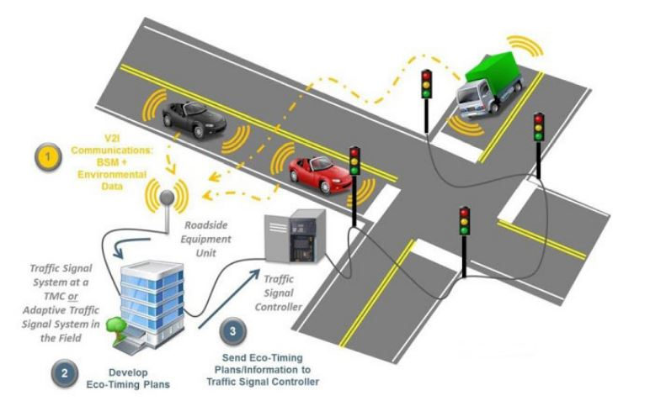

* **Cooperative Intelligent Transport Systems**
* **Intelligent Speed Adaptation**
* **Smart signs**
* **Smart camera crash prevention**
* **Roadside collision avoidance**
* **Night vision**
* **Driver fatigue detection and warning**
* **Collision avoidance technology systems**

**Road safety is crucial and the Government intends to leverage technology for augmenting the safety of citizens. The technology enables you to control traffic, catch the lawbreakers, and provide road safety.**

**LIDAR Gun  
Light Detection and Ranging gun is a weightless and simple tool, which enables law officials to catch and book vehicles that crosses the speed limit. With the invisible infrared beam in the gun, you will be able to target individual vehicles and recognize whether a particular vehicle is violating the speed limit or not, on the basis of variations recorded in the light.**

**Moreover, the device estimates the vehicle’s speed within a second and is devoid of errors. Apart from that, the gun also assists you to establish the distance between two vehicles and detect instances of tailgating. The device enables you to capture and record images of license plates. It has already been implemented by traffic authorities in the US and the UK.**

**Speed Indication Display**

**Warning signs can be beneficial for road users. The speed indication displays – that serve as a warning sign – are digital speed boards which are installed on roads for identifying whether a vehicle crosses the speed limit or not. These devices are installed along with a radar sensor, and can evaluate the speed of the vehicle, which is displayed on the LED displays, visible to all vehicles. Today, a wide range of speed indication display devices is available; while some display the vehicles which are driving under and over speed limits, others display the real-time speed of each vehicle. At times, the device captures and stores images of speeding vehicles. Speed Indication Displays have been implemented in Singapore and UK, and the Indian Government has already suggested the installation of these devices in its scheduled ‘Integrated Traffic Management System’.**

**Speed Governors  
Speed governors, as the name implies, allow you to recognize when a vehicle crosses the decided speed limit. With the sensors attached to the device, you can recognize how swiftly a vehicle is going, and whenever the vehicle attempts to cross the speed limit, it will restrict the air flow and engine fuel. Hence, the vehicle will automatically slow down and stop. Therefore, the speed governor is an ideal solution for vehicles to remain within the speed limit.**

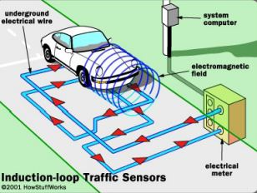

**Variable message signs  
Variable message signs are LED boards which display vital information to commuters. These signs are installed in Indian cities such as Bangalore and Hyderabad. Delhi is also planning to install the sign in the near future. As a  
result, it serves of value to road users as they are able to receive the latest updates on the road and traffic conditions, especially that of vehicle breakdowns and traffic congestion.**

**Induction Loops  
Induction loops are beneficial since they detect vehicles waiting at the junction and send this data to traffic signals, which change automatically based on the situation. These loops utilize electromagnetic fields and will  
experience a change in frequency whenever a vehicle enters that particular area. The feedback obtained from it is transferred via connected cables. In addition to this, the type of vehicle can also be determined on the basis of the changes in frequency**

**Public Private Partnerships – the way forward  
In most countries, traffic enforcement cameras and other road safety equipment are purchased, owned, and operated by government organizations. The past two decades have seen a wide-ranging wave of privatization and introduction of public private partnerships (PPP) in formerly government-owned or controlled activities, including traffic enforcement. Implementing this concept properly and successfully requires a set of principles and good practices.**

**Basic elements of an effective automated traffic enforcement PPP Model  
a. A study to identify the intersections or road sections that have a history of injuries or fatalities with the sole goal of improving road safety at these sites. The study should confirm that – besides safety cameras – a range of road safety countermeasures have been considered and thoroughly evaluated for effectiveness.  
b. A private party – either a supplier or a third party who is willing to supply the safety cameras for usage at no upfront charge to the public party, which could be a municipality, county, province, state, or nation, and provide a service to issue tickets and collect fines for traffic violations recorded by the safety cameras.  
c. A contractual arrangement between the public and private party, allowing the private party to recover its investment over time by receiving an agreed and capped share of the revenue generated by the safety cameras. This contractual cap should not prevent the private party from  
issuing further tickets, which means a reasonable per ticket fee to cover the private party’s additional costs should continue once the cap is reached.  
d. No citations may be issued unless an authorized official has verified the offense after viewing the image or video of the incident.  
e. The end-to-end integrity of the enforcement system (from cameras to back office processes) must be guaranteed  
to ensure public trust and optimise efficacy and efficiency. An independent third party must be hired to formally approve and authorise usage, but also routinely inspect, verify and calibrate each camera to confirm the intended measurements and performances. An independent party should also monitor, inspect and verify that the entire enforcement process from violation registration to fine collection takes place according to agreed-upon performance and integrity indicators.  
f. A clearly publicized campaign that promises that the sole objective of the automated enforcement operation is road safety improvement, and that all revenue above the expenses incurred by private parties (camera supplier and operator as well as the third party hired to audit the cameras and enforcement processes) will be reinvested only in road safety related projects.**

**Controversial issues with enforcement of PPP model:  
a. Not road safety, but revenue driven  
b. Alleged collusion and corruption  
c. Enforcement cameras do not contribute to road safety  
d. Limits other road safety initiatives by public parties**

**We must develop some checks and balances to create transparency and integrity:**

* **Ultimate control and approval of violations only by police or authorised officials**
* **Independent approval and regular verification of accuracy and overall performance**
* **Surplus fine revenue to be reinvested into road safety projects**
* **Longer term contract with capped revenue**
* **Maintain lower financial incentive to continue to issue tickets beyond cap**

**In India, there is a huge potential for such PPP models but the authorities and private investors are still not finding a balance, and are unable to create a clean, non- profit, safety objective-driven campaign to reduce road fatalities. But in the future, as more and more international investor-driven platforms will operate these roads, these models could be a reality soon.**

# Smart Road Technology: Digital Highways Of The Future

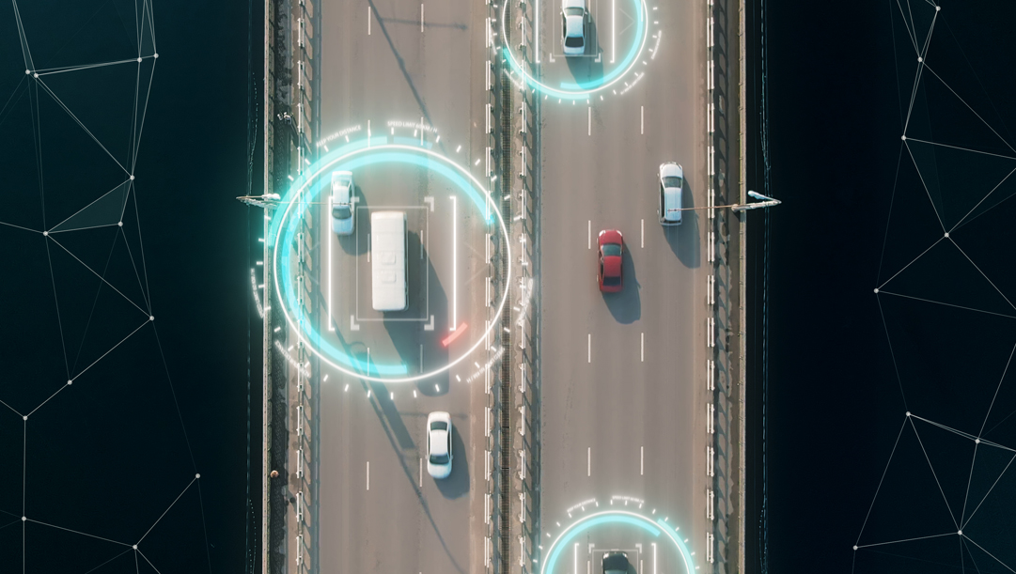

The road is often overlooked when discussing the future development and digital transformation of the modern transport infrastructure. Afterall, we have all heard of connected cars, self-driving cars, gps navigation, route optimization apps and ride-hailing services. You would be forgiven for thinking how the common road fits into this digital revolution, as it turns out, the road itself can be a platform for an amazing array of innovations.

Roads can be upgraded with communication, lighting and power transmission technologies that can support sustainability, improve safety and efficiency which in turn will help transform the driving experience.

### What Is Smart Road Technology?

Smart roads use Internet of Things (IoT) devices to make driving safer, more efficient, and in line with government objectives, greener. Smart roads combine physical infrastructures such as sensors and solar panels with software infrastructure like AI and big data.

Smart road technologies are embedded in roads and can improve visibility, generate energy, communicate with autonomous and connected vehicles, monitor road conditions, and more.

Here are a few examples:

* IoT connectivity: Cities can connect roads to IoT devices, and gather traffic and weather data. This type of connectivity can improve safety, traffic management, and energy efficiency.
* Traffic management networks: For improving safety and reducing congestion. The network uses speed cameras to provide warning signs for hazardous conditions, and sends automated traffic diversion signals that control traffic.
* Traffic lights optimization: Systems that use data from closed-circuit television (CCTV) cameras or smart vehicles to optimize traffic lights and update commuters on jams or bottlenecks.

Most transport-related smart tech focus on individual vehicles, although there have been major advances in technological solutions for smart infrastructure at scale. Worldwide experiments in Vehicle to Infrastructure (V2I), Vehicle to Vehicle (V2V) and Vehicle to Pedestrian (V2P) technologies will make urban transport smarter in the future.

### Digital Reality: 7 Smart Road technologies

1. Solar powered roadways

Photovoltaic cells are embedded within hexagonal panels made of tempered glass, which are used to pave roads. These panels contain LEDs, microprocessors, snow-melting heating devices and inductive charging capability for electric vehicles when driving. Glass is renewable and can be engineered to be stronger than steel, and to allow cars to stop safely even when traveling at high speeds. While this idea has gained widespread support, scalability is a challenge as it remains expensive.

1. Smart Roads

Specially engineered roadways fitted with smart features, including sensors that monitor and report changing road conditions, and WiFi transmitters that provide broadband services to vehicles, homes and businesses. The smart road can also charge electric cars as they drive.

1. Glow in the dark roads

Glowing markers painted onto existing roadway surfaces use a photo-luminescent powder that absorbs and stores daylight. The 500m long strips glow for 8 hours after dark. This technology is still in the testing phase, and the glow is not yet consistent, but it could be more cost-effective than traditional road lighting technologies.

1. Interactive lights

Road lights activated by motion sensors to illuminate a particular section of the road as cars approach. The lights dim once the car passes. Suited for roads with less traffic, interactive lights provide night visibility as needed and reduce energy wastage when there are no cars. One design, developed in Holland, uses the wind generated by passing vehicles to power lights.

1. Electric priority lane for charging electric vehicles

Embedded cables generate magnetic fields that charge electric vehicles while driving. A receiver coil in the vehicle picks up electromagnetic oscillations from a transmitter coil embedded in the road and converts them to AC, which can then power the car. Inductive charging technology already exists for static cars, but future wireless technology could charge batteries while in motion, providing distance range solutions for electric vehicles which travel longer journeys.

1. Weather detection

Networks of AI-integrated sensors detect weather conditions that impact road safety. Road Weather Information Systems (RWIS) in use today are limited because they only collect data from a small set of weather stations. A larger future network could use automated weather stations to collect atmospheric and weather data and instantly upload it to the cloud. Dynamic temperature-sensitive paint could be used to highlight invisible roadway conditions like black ice.

1. Traffic detection

Data that helps travelers plan their routes. Sensors lining highways monitor traffic flow and weight load, warn drivers of traffic jams, and automatically alert the authorities about accidents. Fiber-optic cables embedded in the road detect wear and tear, and communication between vehicles and roads can improve traffic management. For example, rapid flow technologies use artificial intelligence (AI) to manage traffic lights, which respond to each other and to cars. Traditional systems were pre-programmed to optimize flow around peak journey times, new technologies are able to process and optimize flows in real time.

### Adopting Smart Road Technology

Many governments and transport authorities understand the value of smart road technologies. However, developing smart city infrastructure at scale can be costly and complex. Leaders can break down smart road projects into phases, starting with low-investment, narrow-scale initiatives that can provide initial value, setting the stage for high-investment and large-scale efforts.

In the early days of motor-powered mobility, cars were available, but there was no suitable road infrastructure; the first private cars were hardly more effective than horse-driven wagons. Gradually, authorities recognized that only a major investment in road infrastructure would help the population reap the benefits of new transport technology.

Similarly, today’s governments and urban transport authorities are beginning to appreciate the importance of smart roads as an essential platform for mobility innovation. Smart roads will power smarter cars, empower drivers, and provide governments with unprecedented visibility and control over the living fabric of motor-based traffic.